The desperate tales that drive Gaza inhabitants towards the border
Since the start of the “March of Return” movement, hundreds of severely wounded patients have flocked to MSF’s three medical clinics in Gaza.
The patients are mainly young men, in their twenties. They describe their desperation, the impossibility of finding a job, the extreme poverty, the feeling of abandonment. Many go to the border with Israel knowing the risks, but also with the feeling of having nothing to lose. Most hope to heal quickly in order to go back and protest again.
Among the nearly 500 young men on crutches who have filled the MSF clinics' waiting rooms in the past three weeks, there are also several women, older men, and children.
These interviews were conducted on April 16 and 17, 2018, in Khan Yunis and Beit Lahia clinics
Yahya, 11 years old, student
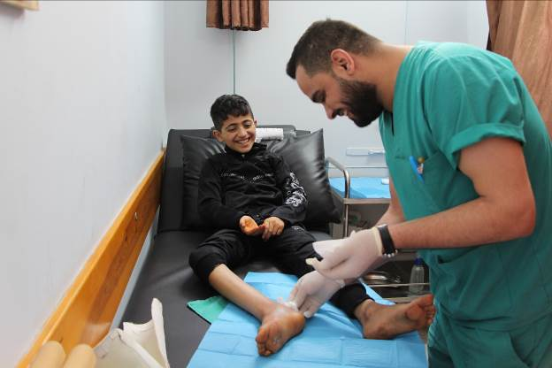
"My name is Yahya, I’m 11 years old and I’m in 5th grade. Before I got hurt I really enjoyed going to school and never had grades below 95/100!

I went to the "Great March of Return" with two of my brothers, to discover the land of my parents, and to see with my own eyes the people who bomb Gaza and shoot Gazans. I wanted to understand why. You know, the only thing that makes Israelis stronger than us is their weapons.

I was very close to the fence when I got shot. I was the only child of my age to be so close. I wanted to get closer to see the landscape on the other side. It was very beautiful, much more beautiful than Gaza! But then I got shot. I remember the face of the person who shot; she was a young blond woman.

I received a bullet at the junction between the foot and the leg. Everything was hurt: the muscles, the tendons, and the bone. I can only move my toes now, and just a little bit. When I was shot, it hurt me a lot, like an electric shock. But now, I feel a little better. I first got surgery at the hospital and I should have another operation. In the meantime, I come three times a week to the MSF clinic in Beit Lahia and I have been told that I should be able to walk again in six months.

I do not think I'm too young to get injured. I can bear the pain and the sorrow, like all the other people in Gaza who have been wounded by gunshot."

Jameel, 50 years old, ice-cream seller
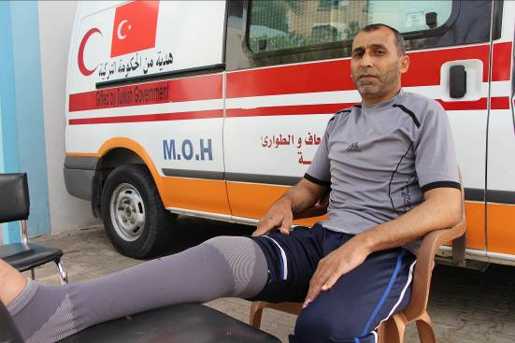
"My name is Jameel and I'm 50 years old. I am an ice cream seller. I’m married and I have four daughters. Of course, I cannot go to work since I was injured, and I do not know when I can start my job again.

I went to the demonstration on March 30 to relieve the stress of the life in Gaza, for a change of atmosphere, but also simply to show that I exist.

I did not have any specific expectation for this day. Moreover, we cannot say that I actively protested; rather, I observed. I was not throwing stones of course, and I was not screaming. I was standing in the middle of a group of people I did not know, 600 meters from the separation barrier, and I ate a snack.

It was then that I suddenly felt a sharp pain in my leg. They had just shot me. I fell and the people around me immediately took me to an ambulance, which took me to the hospital. I lost a lot of blood. When I arrived, my hemoglobin level was 3g / dcl [compared to 12 to 14g / dcl in normal conditions].

There I was operated on, to stop the bleeding. It was 11 a.m. I was one of the first wounded of the march and so I was lucky enough to be operated on quickly. I had a sectioned artery and it's a miracle that they were able to save my life in time. I would need a second surgery, however, and in the meantime, I can’t walk or lower my leg.

I have not been back to the border since then. I am physically unable to do it, but even if I could walk, I would not go. I do not judge people who go there—they have their reasons— but for me it's too difficult. I spend my time reminding myself of the scene. I think about it all the time. What happened? What did I do wrong for them to shoot me? "

Sana, 30 years old, housekeeper
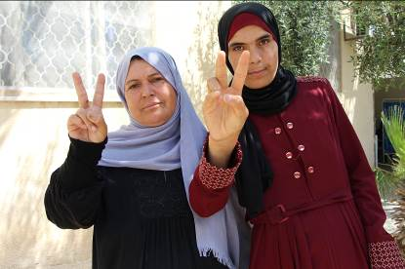
« My name is Sana and I am 30 years old. I live with my family, which consists of 16 people. I am not married so I help my mother with housework. I am very attached to the fight for my country, and my mother before me, took part in many demonstrations

In Gaza there is no hope, no future. People here are poor and we’re dying slowly. I am myself desperate with my life here.
When I left for the march, I wanted to die. To die as a hero is much preferable to the life we ​​have in Gaza. Before leaving, I gave money to my father, so he could buy cakes and treats for my funeral. I said goodbye to everyone. I did not want to come back. I was determined.

My parents and brothers forbade me to go to the demonstration and to get close to the separation barrier, but I went in secret with two of my friends. My mother followed me but she could not find me in the crowd.

My two friends and I were shot and wounded. In my case, I had both legs injured, by two separate shots. A person who came to help me stand and get into an ambulance was also targeted and wounded.

After the demonstration, my family did not know if I was safe, hurt or dead. They searched for four hours in hospitals in southern Gaza, before finding me.

Now, with my injury, I have become a burden to my family. The committee of the wounded refused to give money to my father as compensation because I was not amputated and no bone was affected. I feel abandoned by the leaders of the country I wanted to defend.

I can’t wait to heal, and to go back. My mother tries to dissuade me. It's normal, she's my mother. But I want to die this time. The sign V of victory, is the only hope I have left. "

